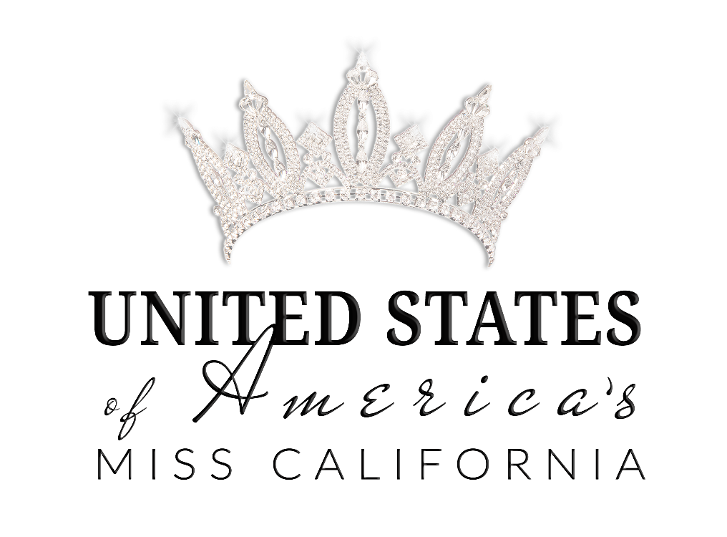

Welcome
to
UNITED STATES of AMERICA PAGEANTS
Miss California

UNITED STATES of AMERICA PAGEANTS are designed to help women ACHIEVE their dreams and make them feel BEAUTIFUL inside and out! Our motto is to EMPOWER Women, INSPIRE others, and UPLIFT everyone! We focus on empowering women, promoting positive self-image and providing an avenue of achievement for today’s modern woman. But more importantly we are an elite sisterhood that provides support and encouragement to inspire each delegate to be the best version of herself!

“There is no tool for development, more effective than the empowerment of women”-Kofi Annan

SCHEDULE OF EVENTS

DAY #1 | Friday  September 18, 2020 | REGISTRATION/ORIENTATION  6:00pm
DAY #2 | Saturday  September 19, 2020 | INTERVIEWS  9am-1pm  REHEARSAL  3:00pm
DAY #3 | Sunday  September 20, 2020 | REHEARSAL  9:30AM  FINAL COMPETITION  6:00pm  Doors open for contestants  3:00pm

*Schedule subject to change

PAGEANT VENUE AND HOTEL
Downey Theater
&
Hotel TBD

ELIGIBILITY REQUIREMENTS
As of January 1, 2020

Age Divisions:
UNITED STATES OF AMERICA’S TEEN: Ages 13-17
UNITED STATES OF AMERICA’S MISS: Ages 18-28
UNITED STATES OF AMERICA’S MS. 29+
UNITED STATES OF AMERICA’S MRS. 18+ (Married)
﻿1. Is a U.S. citizen, naturalized or has been granted Permanent residency by the United States
2. Is a resident, works, or goes to school in the state they are competing.
3. Is a natural born female.
4. Has never posed nude in film or print media.

WARDROBE REQUIREMENTS

Opening Number- Opening number dress will be provided, you will need to give the Director your Size before July1, 2020 and wear silver or nude colored shoes.

Interview Outfit- You will need a nice dress or skirt suit, something that reflects your style and personality. The outfit you select should be suitable for a job interview. Solid colors work best.

Swimsuit- You will have the choice to wear a one piece or a two-piece swimsuit. You will need clear or nude colored shoes. Wraps or sarongs are optional. No thongs will be allowed, and bottoms must provide adequate coverage.

Fitness Outfit- Fitness wear is your choice. You will need to wear athletic shoes.

Evening Gown- You will need a floor length formal dress, any style, any color. The value of the gown will not be evaluated. Select a dress that flatters your figure, complexion, and makes you feel beautiful!

Backstage rules and regulations

No one is allowed in the backstage dressing area during the pageant other than the contestants and Sponsors ie: makeup artist, hairdressers. We will have staff backstage to help with changing if necessary.

AREAS OF COMPETITION

Judging Criteria

Personal Interview

In this segment of the competition, each Delegate is judged individually by four judges in round robin format. The Judges will have approximately three (3) minutes with each Delegate.

Judging Criteria:
Content of Judges Bio, Knowledge, Perception, Self-Expression, Spontaneity and Personality will be evaluated. Also important are the Use of Vocabulary, Voice, Appearance and Grooming. Here are some things the Judges will be thinking about:

How well did the Contestant answer the question in terms of content and knowledge?
How quickly was the contestant able to think on her feet?
How articulate and personable was she?

Swimsuit Competition

Judging Criteria:
Confidence, Choice of Swimsuit, Poise, Posture and Execution of Movement will be evaluated. Here are some of the questions the Judges will be thinking about during this segment of the competition:

How well did the contestant model her swimsuit in terms of style and grace?
How well did the contestant’s swimsuit flatter her particular figure?
How well did the contestant convey confidence with body type & choice of swimsuit?

Evening Gown Competition

Judging Criteria:
Confidence, Choice of Evening Gown, Poise, Posture, Personality, Charm, Style, Charisma, Grace, Execution, Overall Appearance and Stage Presence will be evaluated. Here are some of the questions the Judges will be thinking about during the Evening Gown Competition.

How well did the contestant model her gown in terms of technique and elegance?
How well did the contestant’s gown flatter her figure?
How well did the contestant convey confidence with body type and choice of gown?

Onstage Question-

Judging Criteria: Knowledge, Spontaneity, Personality, Vocabulary, Voice, Confidence, and Sense of Values will be evaluated. Here are some of the questions the Judges will be considering during the On-Stage Interview Competition:

How well did the contestant answer the question in terms of content and knowledge?
How quickly was the contestant able to think on her feet?
How articulate and personable was she?

In the event of a tie, the delegate with the higher interview score shall prevail as the winner.
*Judge’s decisions are FINAL!

Entry Fees
$595
Includes:
- Official entry to participate in the annual competition
- Official State title holder’s embroidered sash
- Local Title Crown
- Opening Number Dress
- State Program Book
- Local/ State Photo Shoot
- Pageant Coaching Sponsor Package
- Contestant Swag Bag

Payment Information

Payment #1- $195 Deposit due immediately with the Application; Reserves Local Title
Payment #2- $200 Orders Sash & Crown (allow 3-5 weeks for sash & crown)
Payment #3- $200 Ships Sash & Crown
Payment #4- $299 Full Page Ad (Due no later than two months prior to pageant)

All payments can be made through the Delegate Portal, Venmo, Cash, or Check.

Check: Autumn Grant

Venmo: @USOAMissCA

REQUIRED ADVERTISEMENT PAGE
Each Contestant will need to have ONE FULL PAGE COLOR ADVERTISEMENT in the Program Book, a fee of $299. This can be private or sponsored.

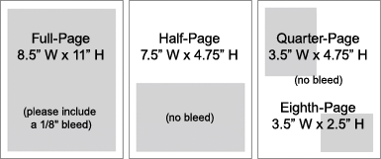

Fundraising Programs
To help with the associated costs of competition you can sell ADDITIONAL advertisements in the program book and earn money! We have set up an incentive program for you to help offset your expenses. Listed below are the available advertisements, their costs, and the amount that you will receive for selling the advertisement! You will be provided a sponsorship letter to help you secure sponsors.
The delegate with the most advertisement sales will receive an onstage award!
You will also receive a $50 credit for every new delegate in any division that you refer that competes!

All payments can be made through Delegate Portal, Venmo, Cash, or Check.

Check: Autumn Grant

Venmo: @USOAMissCA

Available Advertising in Official State Pageant Program Book

Advertisement | Advertisement Cost | Incentive
Back Cover | $750 | $450
Inside Covers | $550 | $250
Two Page Spread | $500 | $225
Full Page | $299 | $125
Half Page | $150 | $50
Quarter Page | $75 | $25

DOCUMENTS NEEDED

To compete in the Pageant, you MUST turn in the following.

- Official Application- Due Immediately
- Deposit- Due Immediately
- Official Paperwork- Due Immediately
- Title holders agreement
- Credit Card Authorization Form (Only used if in violation of contract or on delinquent accounts)
- Indemnity Contract
- Photo release
- Advertising release
4. Headshot, professional photo, NO sash and crowns allowed
5. Copy of birth certificate, naturalization, or permanent resident card
6. Copy of driver’s license or identification card
7. Final divorce decree for any previously married MS contestants
8. Ad Page artwork/fees/forms (as soon as they are ready, but NO LATER than one month prior to the pageant)
9. MRS- Copy of marriage license.
10. Any other documents requested by director.
11. Judges Bio Form- 6 hard copies, typed and three hole punched! (Due 2 weeks before pageant weekend)

*Items 4-10 are due no later than ONE MONTH before the pageant

FAQ’S

Do I have to compete in and win a preliminary competition in order to compete in the national pageant?
There may or may not be STATE preliminaries available in your area, if there is not an official pageant in your state, you will apply directly with the national office.

How long does it take to receive my sash and crown?
Once the sash is ordered it generally takes 4-5 weeks for production.

Is there a minimum amount of tickets I am required to sell? NO!

Do I get a free ticket for my parent or husband?
NO! Everyone must purchase a ticket to attend the pageant.

When do tickets go on sale?
July 1, 2020

Do children under 5 need a ticket?
YES! Everyone needs a ticket.

Am I required to use the official Program designer to create my AD PAGE?
No, you can submit a page already put together or we will put one together for you.

Are there any required rehearsals prior to the pageant?
No. All rehearsals will take place during pageant weekend.

How do I sell advertisements in the program book to raise money towards my pageant expenses?
Once you are registered as a contestant, you will be provided a sponsorship letter to present to businesses, friends and family whom may wish to support you by either purchasing an advertisement to simply wish you good luck or to promote and highlight their business!

See you soon!
Love your Director,
Autumn Lynn
Executive Director
USOA Miss California
california@unitedstatesofamericapageants.com

